Project Report
On
Computer Networking: Concepts (CSE3751)


Inter-Campus Mail Server Network Using SMTP/POP3/IMAP

Submitted by:

Name: Udbhav Ashish Arya Regd. No.: 2341001108
Name: Tejaswi Sharma Regd. No.: 2341019432
Name: Samridhi Shandilya Regd. No.: 2341019398
Name: Akshat Regd. No.: 2341011224
Name: Shrieesha Pandey Regd. No.: 2341016130
B. Tech. CSIT 5th Semester (Section 23413C1)
INSTITUTE OF TECHNICAL EDUCATION AND RESEARCH
(FACULTY OF ENGINEERING)
SIKSHA ‘O’ ANUSANDHAN (DEEMED TO BE UNIVERSITY), BHUBANESWAR, ODISHA

i

Declaration

We, the undersigned students of B. Tech. of CSIT Department hereby declare that we own the full responsibility for the information, results etc. provided in this PROJECT titled “Inter-Campus Mail Server Network Using SMTP/POP3/IMAP submitted to Siksha ‘O’ Anusandhan (Deemed to be University), Bhubaneswar for the partial fulfillment of the subject Computer Networking: Concepts (CSE 3751). We have taken care in all respect to honor the intellectual property right and have acknowledged the contribution of others for using them in academic purpose and further declare that in case of any violation of intellectual property right or copyright we, as the candidate(s), will be fully responsible for the same.

Name: Udbhav Ashish Arya Regd. No.: 2341001108

Name: Tejaswi Sharma Regd. No.: 2341019432

Name: Samridhi Shandilya Regd. No.: 2341019398

Name: Akshat Kumar Regd. No.: 2341011224

Name: Shrieesha Pandey Regd. No.: 2341016130

Date: 23/12/2025

Place: ITER, Bhubaneswar, Odisha

Abstract
This project demonstrates the design and simulation of a multi-campus network infrastructure capable of supporting secure email communication across geographically separated locations. Using Cisco Packet Tracer, a network topology was created connecting three distinct campuses—Main, North, and South—via a WAN infrastructure.
The primary objective was to implement a scalable routing solution using OSPF (Open Shortest Path First) to ensure dynamic connectivity between disparate VLANs (Staff, Student, and Server segments).
Furthermore, the project focused on deploying essential application-layer services, specifically SMTP and POP3 protocols for email exchange and DNS for domain name resolution. A critical component of the design involved securing the network using Extended Access Control Lists (ACLs) to strictly permit email and routing traffic while denying unauthorized ICMP ping requests.
The successful transmission of email across the routed network, verified through simulation logs, confirms the viability of this architecture for enterprise-level communication requirements.

Contents

Serial  No. | Chapter No. | Title of the Chapter | Page No.
1. | 1 | Introduction | 1
2. | 2 | Problem Statement | 2
3. | 3 | Methodology | 3
4. | 4 | Results and interpretation | 5
5. | 5 | Conclusion | 7
7. |  | References | 8

- Introduction

In modern enterprise environments, reliable and secure communication is paramount. This project involves the simulation of an inter-campus network connecting three sites: a central Main campus and two satellite campuses (North and South).

The network utilizes a hierarchical design with local switching and centralized routing. The core purpose is to establish a functional email system where users from different departments (Staff and Students) can exchange messages seamlessly across the WAN.

The project integrates fundamental networking concepts—including VLAN segmentation, Inter-VLAN routing, dynamic OSPF routing, and application-layer service deployment—into a cohesive system. It serves as a practical demonstration of how network protocols interact to support user applications while adhering to security best practices through traffic filtering..

- Problem Statement

The challenge is to design a robust communication system for an organization spanning three separate campuses that requires internal and cross-campus email capabilities.
Objectives & Identification of Objects:
- Scalability: Implement OSPF routing to handle connectivity between routers (R-Main, R-North, R-South) without manual static route maintenance.
- Segmentation: Utilize Switches (SW-Main, SW-North, SW-South) to create VLANs (10, 20, 99) for logically separating Staff, Student, and Server traffic.
- Service Availability: Deploy Servers to handle SMTP (port 25) and POP3 (port 110) traffic, supported by a central DNS server.
- Security Constraints: The network must enforce a security policy that allows only mail, DNS, and OSPF traffic. All other traffic, specifically ICMP (Ping), must be blocked between campuses to prevent network scanning and unauthorized reachability checks.

- Methodology

Designing the Topology: The network was constructed using a star-like WAN topology where the Main Campus router acts as a central hub connecting to North and South routers via Serial links. Each campus features a Router-on-a-Stick configuration, connecting a router to a Layer 2 switch via a trunk link to support multiple VLANs.
Configuring the Devices:
- VLANs & Trunks: Created VLANs 10 (Staff), 20 (Students), and 99 (Servers) on all switches. Configured trunk ports to carry tagged frames to the routers.
- Addressing & Routing: Assigned unique subnets to each VLAN (e.g., Main uses 192.168.10.x, North uses 192.168.30.x). OSPF Process ID 1 was enabled on all routers to advertise these networks dynamically.
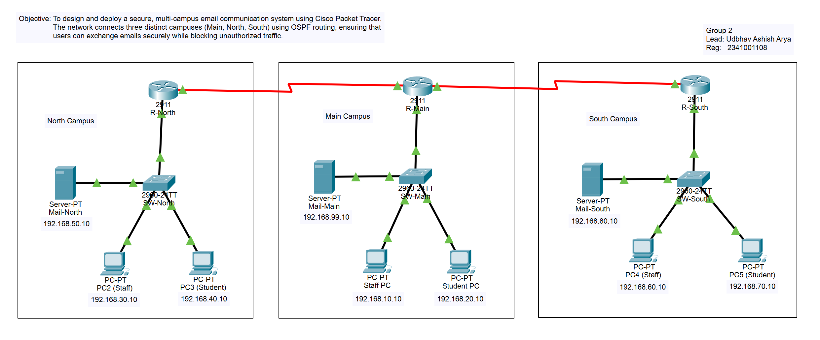
- Services: Configured Email services on servers with distinct domains (main.edu, north.edu, south.edu) and set up a central DNS on the Main server to resolve these names.

(Figure 1: Complete Network Topology connecting three campuses).

CLI Instructions (Key Configurations):
- OSPF Configuration (R-Main):
router ospf 1
network 10.1.1.0 0.0.0.3 area 0
network 192.168.10.0 0.0.0.255 area 0
- ACL Configuration (Security):
access-list 100 permit tcp any any eq 25
access-list 100 permit tcp any any eq 110
access-list 100 permit tcp any any established
access-list 100 deny ip any any

- Results & Interpretation
The implementation was verified through a series of connectivity and service tests.
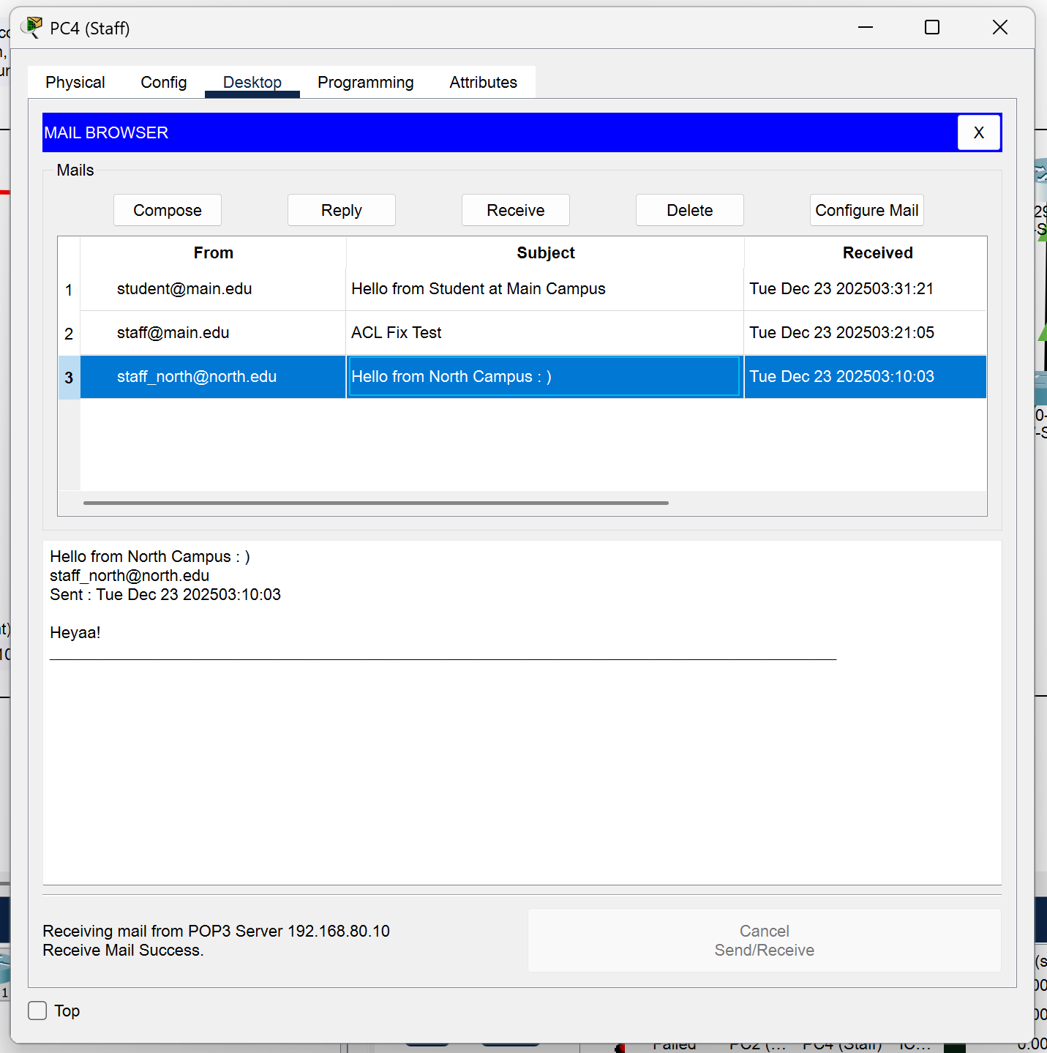
- Successful Email Transmission: The primary objective was met when an email sent from the North Campus Student PC (student_north@north.edu) was successfully received by the South Campus Staff PC (staff_south@south.edu). This confirms that DNS resolution, OSPF routing, and SMTP/POP3 services are functional.

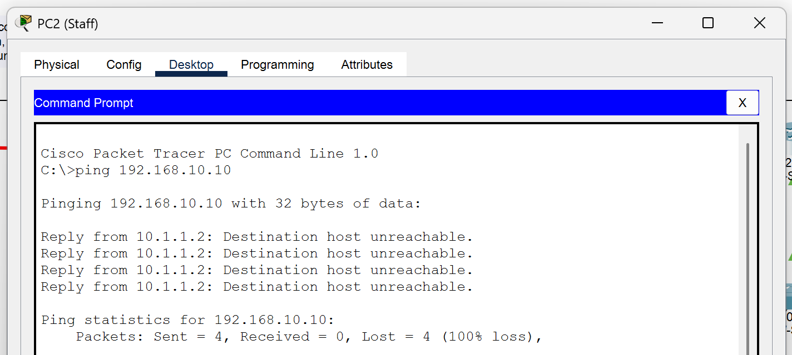
- Security Verification (Ping Failure): To verify the ACL, a ping test was conducted from North Campus to South Campus. The output Destination Host Unreachable or Request Timed Out confirms that the ACL correctly blocked ICMP traffic while allowing the email traffic demonstrated above.

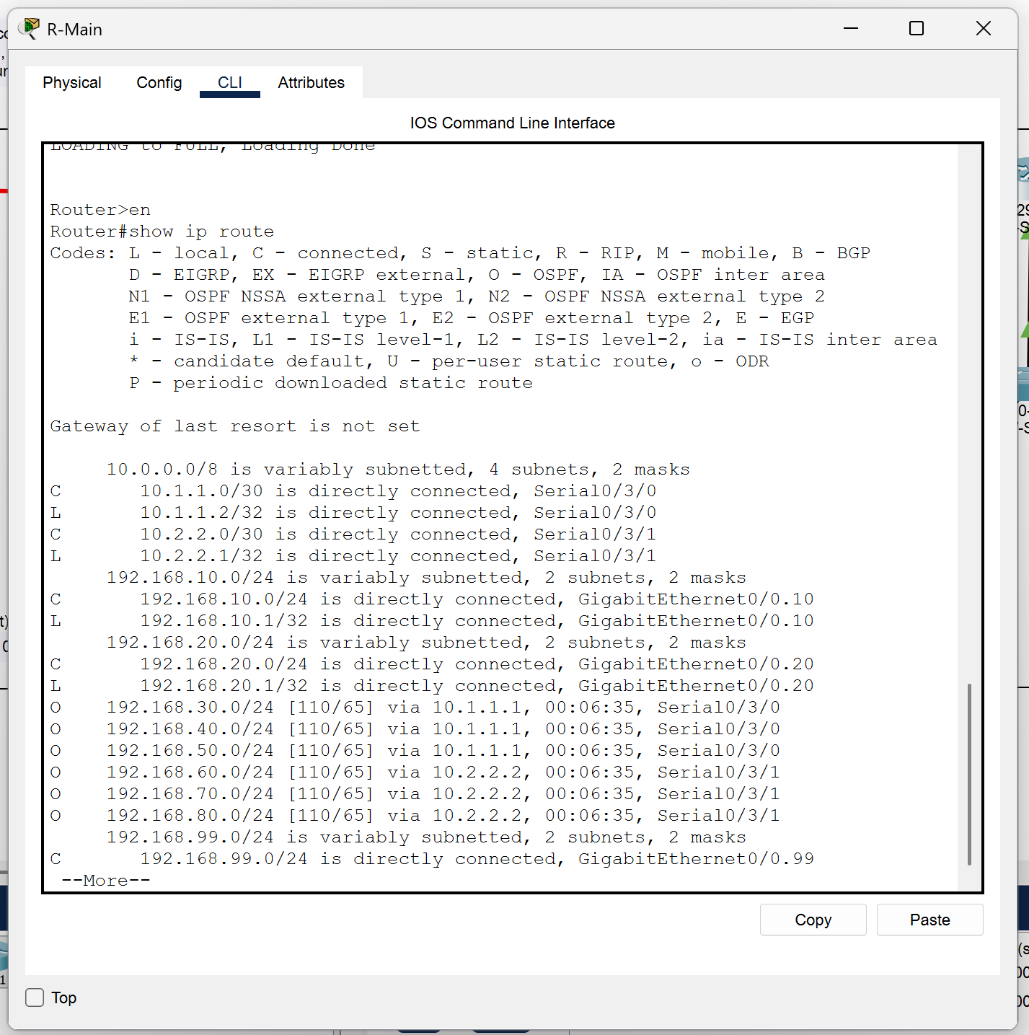
- Routing Verification: The show ip route command on R-Main displayed "O" (OSPF) entries, confirming that the router successfully learned the paths to the remote North (192.168.30.0) and South (192.168.60.0) networks.
- Conclusion
This project successfully achieved the design and implementation of a secure, multi-campus email network. By integrating OSPF for dynamic routing, the network ensured resilient connectivity between the Main, North, and South campuses.
The logical segmentation provided by VLANs improved network management, while the deployment of ACLs satisfied the critical security requirement of restricting non-email traffic. The successful exchange of emails across the simulated WAN, coupled with the verified blocking of ICMP packets, demonstrates a functional and secure network design that meets all specified project deliverables.

References

[1] CompTIA Network+ N10-008 Certification Guide by Glen D. Singh, 2nd Edition, Packt publication.
[2] Cisco Networking Academy, CCNA 2: Routing and Switching Essentials, Cisco Systems, 2020.
[3] "RFC 2328 - OSPF Version 2," Internet Engineering Task Force (IETF), April 1998.
[4] "Packet Tracer - Configuring ACLs," Cisco Networking Academy Lab Manual, 2021.
[5] "RFC 5321 - Simple Mail Transfer Protocol," Internet Engineering Task Force (IETF), October 2008.

